1. What is Big Data and What is PySpark?
What is Big Data?
Big Data refers to extremely large and complex datasets that cannot be efficiently processed, stored, or analyzed using traditional database systems and tools. These datasets are generated from various sources such as social media, online transactions, sensors, mobile devices, websites, and enterprise applications.
Big Data is commonly characterized by the 5 Vs:
- Volume – Massive amounts of data generated every second.
- Velocity – The speed at which data is created and processed.
- Variety – Different types of data, including structured, semi-structured, and unstructured data.
- Veracity – The reliability and quality of the data.
- Value – The useful insights and business benefits derived from the data.
Examples of Big Data
- Social media platforms processing billions of posts and comments.
- E-commerce websites tracking customer behavior and purchases.
- Banking systems analyzing millions of transactions daily.
- IoT devices generating sensor data continuously.
Challenges of Big Data
- Storage of huge datasets.
- Fast data processing and analysis.
- Scalability across multiple machines.
- Handling diverse data formats.
- Ensuring data security and quality.
To address these challenges, distributed computing frameworks such as Apache Spark are used.

What is PySpark?
PySpark is the Python API for Apache Spark, an open-source distributed computing framework designed for processing large-scale datasets quickly and efficiently.
PySpark allows developers and data engineers to write Spark applications using Python while leveraging Spark's powerful distributed processing capabilities.
Why PySpark?
Traditional Python programs process data on a single machine, which becomes slow and inefficient when dealing with terabytes or petabytes of data. PySpark distributes data and computations across multiple machines (nodes) in a cluster, enabling parallel processing and faster execution.
Key Features of PySpark
- Distributed Processing: Processes data across multiple machines simultaneously.
- High Performance: Uses in-memory computation, making it much faster than traditional disk-based systems.
- Scalability: Can scale from a single machine to thousands of nodes.
- Fault Tolerance: Automatically recovers from node failures.
- Easy Integration: Works with Hadoop, Hive, HDFS, Kafka, and cloud platforms.
- Python-Friendly: Enables Spark programming using familiar Python syntax.
Main Components of PySpark
- Spark Core – Fundamental engine for distributed processing.
- Spark SQL – Query structured data using SQL.
- DataFrame API – Efficient processing of structured and semi-structured data.
- Spark Streaming – Real-time data processing.
- MLlib – Machine learning library.
- GraphX – Graph processing (available mainly in Scala).
Simple PySpark Example
from pyspark.sql import SparkSession
spark = SparkSession.builder \
.appName("My First PySpark App") \
.getOrCreate()
data = [("Alice", 25), ("Bob", 30)]
df = spark.createDataFrame(data, ["Name", "Age"])
df.show()

Difference Between Big Data and PySpark
Big Data | PySpark
Refers to large and complex datasets. | A tool/framework used to process Big Data.
It is a concept. | It is a technology.
Deals with data storage, processing, and analysis challenges. | Provides distributed computing capabilities to solve those challenges.
Generated from various sources. | Processes data using Apache Spark and Python.

Conclusion
Big Data represents massive datasets that exceed the capabilities of traditional data processing systems. PySpark is a powerful Python-based interface for Apache Spark that enables fast, scalable, and fault-tolerant processing of Big Data across distributed clusters. Together, Big Data and PySpark form the foundation of modern data engineering and analytics solutions.

2. Spark's Basic Architecture
Introduction
Apache Spark follows a master-worker architecture that enables distributed processing of large datasets across multiple machines. Instead of processing data on a single system, Spark divides the work into smaller tasks and distributes them across a cluster, resulting in faster and more efficient computation.
The Spark architecture consists of several key components that work together to execute applications in a distributed environment.
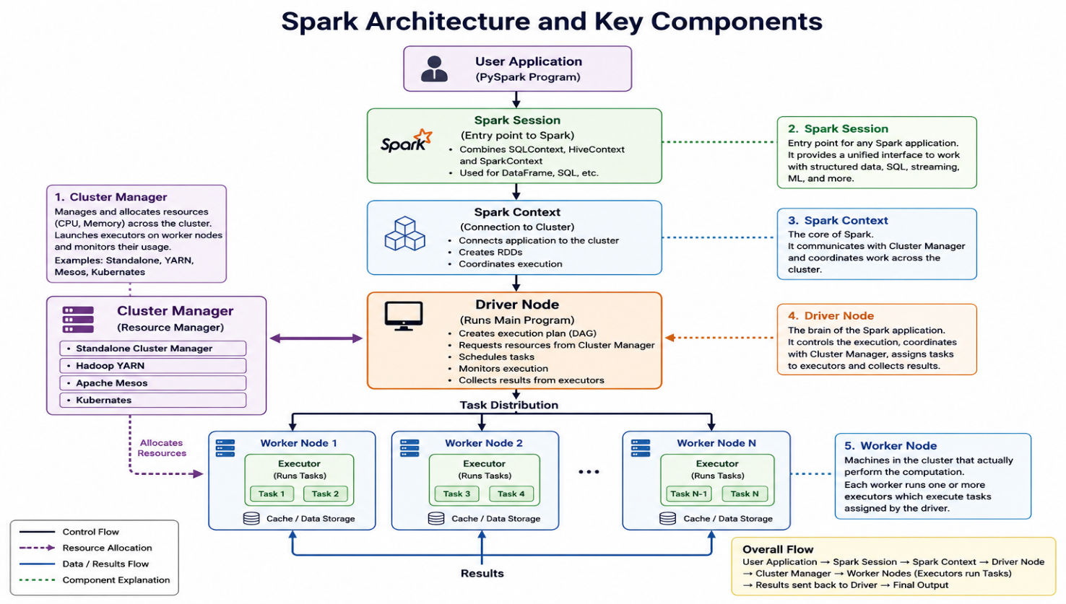
Components of Spark Architecture
1. Driver Program
The Driver Program is the main process that controls the execution of a Spark application.
Responsibilities:
- Creates the SparkSession.
- Converts user code into execution plans.
- Schedules tasks.
- Coordinates with the Cluster Manager.
- Collects results from worker nodes.
The driver acts as the brain of the Spark application.

2. Cluster Manager
The Cluster Manager is responsible for managing resources across the cluster.
Responsibilities:
- Allocates CPU and memory resources.
- Launches executors on worker nodes.
- Monitors resource utilization.
Spark can work with different cluster managers such as:
- Standalone Cluster Manager
- Hadoop YARN
- Apache Mesos
- Kubernetes

3. Worker Nodes
Worker Nodes are machines in the cluster that perform the actual data processing.
Responsibilities:
- Execute assigned tasks.
- Store cached data.
- Run executor processes.
A cluster may contain multiple worker nodes.

4. Executors
Executors are processes launched on worker nodes.
Responsibilities:
- Execute tasks assigned by the driver.
- Store data in memory or disk.
- Return results to the driver.
5. Tasks
A Task is the smallest unit of work in Spark.
When Spark divides a job into multiple partitions, each partition is processed by a separate task.
Example:
- Dataset has 100 partitions.
- Spark creates 100 tasks.
- Tasks run in parallel on available executors.

6. Jobs and Stages
Job
A job is created whenever an action is performed.
Examples of actions:
show()
count()
collect()
save()
Stage
A job is divided into stages based on data shuffling operations.
Spark automatically creates stages to optimize execution.

Spark Architecture Workflow
Step 1: User Submits Application
The user writes a PySpark program and submits it to the Spark cluster.
df.filter(df.age > 25).show()

Step 2: Driver Creates Execution Plan
The Driver Program analyzes the code and creates a logical and physical execution plan.
Step 3: Resource Allocation
The Driver requests resources from the Cluster Manager.
The Cluster Manager launches executors on worker nodes.

Step 4: Task Distribution
The Driver divides the job into stages and tasks.
Tasks are distributed among executors running on worker nodes.
Step 5: Parallel Processing
Executors process data in parallel across multiple machines.
Example:
Worker 1 → Task 1
Worker 2 → Task 2
Worker 3 → Task 3
Worker 4 → Task 4
All tasks run simultaneously.

Step 6: Result Collection
After processing, executors send results back to the Driver Program.
The Driver combines the results and presents the final output to the user.
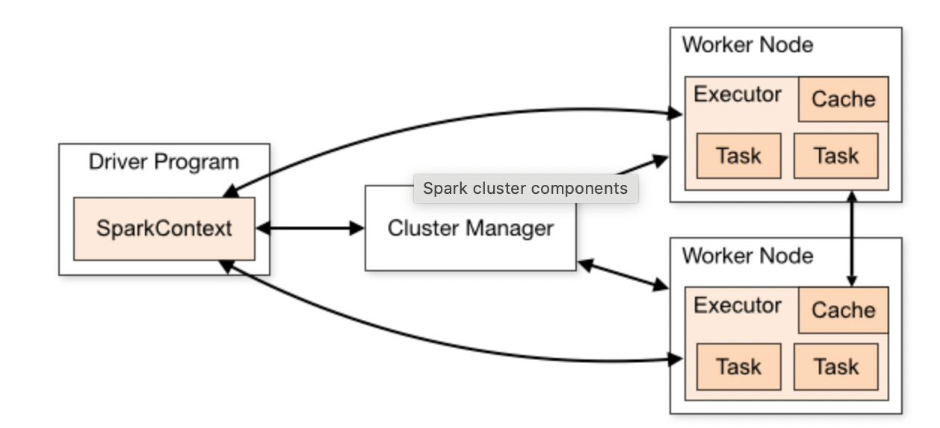
3. Cluster Manager, Spark Session, Spark Context, Driver Node, Worker Node
Introduction
Apache Spark uses a distributed architecture where different components work together to process large datasets efficiently. Some of the most important components are Cluster Manager, Spark Session, Spark Context, Driver Node, and Worker Node. Understanding these components is essential for learning how Spark applications run in a cluster environment.

3.1 Cluster Manager
Definition
A Cluster Manager is responsible for managing and allocating resources (CPU, memory, and executors) across the Spark cluster.
It acts as a resource coordinator between the Driver and Worker Nodes.
Responsibilities
- Allocates resources to Spark applications.
- Launches executors on worker nodes.
- Monitors cluster resource usage.
- Manages application execution.
Types of Cluster Managers
1. Standalone Cluster Manager
Spark's built-in cluster manager.
2. Hadoop YARN
Used when Spark runs on Hadoop clusters.
3. Apache Mesos
General-purpose cluster manager.
4. Kubernetes
Container-based cluster management platform.
Example Flow
Driver Program
|
v
Cluster Manager
|
v
Allocates Executors
|
v
Worker Nodes

3.2 Spark Session
Definition
A SparkSession is the entry point to any Spark application.
Introduced in Spark 2.0, it combines the functionalities of:
- SparkContext
- SQLContext
- HiveContext
into a single unified interface.
Why SparkSession?
Before Spark 2.0, developers needed multiple contexts to work with Spark features. SparkSession simplifies development by providing a single access point.
Creating a Spark Session
from pyspark.sql import SparkSession
spark = SparkSession.builder \
.appName("MySparkApp") \
.getOrCreate()
Common Operations
Read Data
df = spark.read.csv("employees.csv", header=True)
Run SQL Queries
df.createOrReplaceTempView("employees")
spark.sql(
"SELECT * FROM employees"
).show()
Stop Session
spark.stop()
Importance
- Entry point for PySpark applications.
- Used for DataFrame and SQL operations.
- Automatically creates SparkContext.

3.3 Spark Context
Definition
SparkContext is the core component that establishes communication between the Spark application and the cluster.
It is often called the "heart of Spark."
Responsibilities
- Connects Spark application to the cluster.
- Creates RDDs.
- Schedules tasks.
- Communicates with the Cluster Manager.
- Coordinates execution across worker nodes.
Accessing SparkContext
sc = spark.sparkContext
Example
rdd = sc.parallelize([1, 2, 3, 4, 5])
print(rdd.collect())
Output
[1, 2, 3, 4, 5]
Relationship with SparkSession
SparkSession
|
v
SparkContext
|
v
Cluster Manager
SparkSession internally creates and manages SparkContext.

3.4 Driver Node
Definition
The Driver Node is the machine where the main Spark application runs.
It contains:
- SparkSession
- SparkContext
- Driver Program
The Driver Node controls the execution of the entire application.
Responsibilities
1. Creates Execution Plan
Converts user code into executable tasks.
2. Requests Resources
Communicates with the Cluster Manager.
3. Schedules Tasks
Assigns tasks to executors.
4. Collects Results
Receives processed data from worker nodes.
Example
df.filter(df.salary > 50000).show()
The Driver Node:
- Receives the command.
- Creates execution plan.
- Divides work into tasks.
- Sends tasks to workers.
- Collects results.
Driver Node Diagram
Driver Node
|
+-- SparkSession
|
+-- SparkContext
|
+-- Task Scheduler

3.5 Worker Node
Definition
A Worker Node is a machine in the Spark cluster that performs the actual data processing.
Worker Nodes receive tasks from the Driver Node and execute them using Executors.
Responsibilities
- Execute assigned tasks.
- Store cached data.
- Process data partitions.
- Return results to Driver Node.
Executors on Worker Nodes
Each worker node runs one or more executors.
Worker Node
|
+-- Executor 1
|
+-- Executor 2
Example
Suppose a dataset has 4 partitions.
Partition 1 → Worker 1
Partition 2 → Worker 2
Partition 3 → Worker 3
Partition 4 → Worker 4
Each worker processes its partition in parallel.
Benefits
- Parallel processing.
- Faster execution.
- Scalability.
- Fault tolerance.

4. What is Client Mode and Cluster Mode?
Introduction
In Apache Spark, Client Mode and Cluster Mode describe where the Driver Program runs when a Spark application is submitted to a cluster.
The main difference is the location of the Driver.
Client Mode
In Client Mode, the Driver Program runs on the client machine, which is the machine from where the user submits the Spark application.
The client machine stays connected to the cluster until the application finishes.
Features of Client Mode
- Driver runs on the local/client machine.
- Executors run on worker nodes.
- Useful for development, testing, and debugging.
- The client machine must remain active during execution.
- If the client machine fails, the Spark application may fail.
Example
spark-submit --deploy-mode client app.py
Client Mode Flow
Client Machine
|
|-- Driver Program
|
v
Cluster Manager
|
v
Worker Nodes → Executors → Tasks

Cluster Mode
In Cluster Mode, the Driver Program runs inside the cluster, usually on one of the worker nodes.
After submitting the application, the client machine does not need to stay connected.
Features of Cluster Mode
- Driver runs inside the cluster.
- Executors also run on worker nodes.
- Best for production jobs.
- More reliable for long-running applications.
- Client machine can disconnect after submission.
Example
spark-submit --deploy-mode cluster app.py
Cluster Mode Flow
Client Machine
|
v
Cluster Manager
|
v
Worker Node
|
|-- Driver Program
|
v
Other Worker Nodes → Executors → Tasks
Difference Between Client Mode and Cluster Mode
Client Mode | Cluster Mode
Driver runs on the client machine. | Driver runs inside the cluster.
Client must stay connected. | Client can disconnect after submission.
Suitable for testing and debugging. | Suitable for production jobs.
Less reliable for long-running jobs. | More reliable for long-running jobs.
Logs are available on the client machine. | Logs are available in cluster logs.

